A Flexible Plastic Micromixer for Immunosensor Application

Senaka Kanakamedala^{1,2}, Ji Fang¹, and Mark DeCoster^{1,2}

¹Institute for Micromanufacturing, Louisiana Tech University
²Centre for Biomedical Engineering Rehabilitation Science, Louisiana Tech University

Abstract: We report a simple inexpensive and flexible micromixer developed using a rapid fabrication process for immunosensor application. The micromixer was fabricated using polyester sheet and polyimide tape with silicone adhesive. Xurography rapid prototyping was used to fabricate the micromixer and the whole mixer can be fabricated in less than half an hour. Mixing efficiency was evaluated by injecting two food coloring dyes through the two inlets and collecting the sample at outlet. Mixing efficiency was quantitatively measured by analyzing the RGB values of the image collected from the microscope at inlet and outlet locations. The mixing efficacy of the previously developed micromixers was also evaluated using image analysis method and the results indicate that the mixing efficiency of this polymer micromixer was 95% at Reynolds number (Re) =1 (higher than the previous generations).

Keywords: Flexible micromixer, immunosensor, xurography, polyester, polyimide.

- Introduction

Fluid handling at the microscale greatly affected different fields including biomedical, pharmaceutical, biochemical engineering and environmental monitoring. This led to the evolution of a new concept called microfluidics. Over the past decade, microfluidic device development has been increased rapidly due to their reduced reagent consumption, portability, high throughput, lower hardware cost and shorter analysis time compared to large devices. Since then different microfluidic structures have been proposed by considering different factors such as operation principle, device performance, fabrication method, and materials used. The components of these microfluidic devices include micropump, micromixer, microactuator, and microvalve. Among which micromixer is the key component as the mixing time determines the analysis speed of the devices [1].

Viscous forces dominate the molecular forces when considering mixing at the microscale. So, it is difficult to generate turbulent flow at this low Reynolds number (Re) regime. Thus the effective mixing in microfluidic devices is challenging due to the laminar and stable flow of the fluids. Transverse flow in microscale can be created by employing active and passive micromixing principles. Active mixers improve mixing relying on the external applied disturbance. The complex fabrication process and components to create external disturbances made the integration of these mixers in microfluidic systems both challenging and expensive. On the other hand mixing in passive mixers does not require external energy rather it completely relied on molecular diffusion or chaotic advection [2]. Various passive micromixers have been proposed recently employing either of these two phenomena [1]. This paper reports a low cost, flexible polymer micromixer having mixing efficiency more than 90% across a wide range of Re (from 0.1-30) and also mixing efficiency is constant with various bending angles.

2. Experimental Procedures
2.1 Fabrication
The mask was designed using Adobe Illustrator CS3 vector graphics editor. A polyester sheet was sandwiched between two double sided polyester tapes. The cutting plotter was used to cut the sandwiched polymer sheet according to the specified mask design. The unwanted portion of the tape was peeled off using tweezers. Later this patterned polymer sheet was further sandwiched between two polyester sheets. The sandwiched sheet was heated on a hotplate at 100ºC for 10 min. to improve the bond strength. Inlet and outlet holes were made by diamond cutter and later PDMS ports were attached to the inlet and outlet holes for injecting and collecting fluids. Fig 1 depicts the solid works modes of the fabricated device. The channel depth is ~ 350 μm.

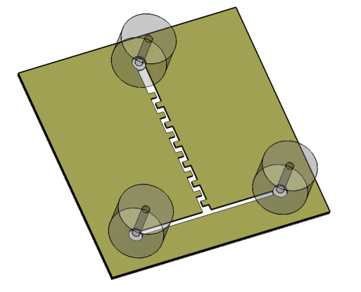
Outlet
Inlet 1
Inlet 2

Fig. 1 Solid works model of the fabricated micromixer (Top view).
2.2 Quantification of Mixing Efficiency
Two food coloring dyes (red and blue) were injected through the two inlets to monitor the mixing efficiency. The quantitative measure of the mixing was done.Image Pro Analysis software was used to quantify the mixing efficacy using the images obtained from the microscope. To measure mixing index, standard deviations of primary colors (red, green, and blue) were measured at inlet and outlet sections of the mixer. Later, the standard deviations of these red, green, and blue pixel values were averaged at the inlet and outlet section respectively. The averaged standard deviation is the measure of color gradient at each section. Then, mixing index was calculated using the following equation.
Where σ_{inlet} is the averaged standard deviation at inlet section and σ_{outlet} is the averaged standard deviation at the outlet section.
3. Results and Discussion
The mixing efficiency of the previously fabricated three generations was measured using image analysis method and the results were compared with the newly developed polymer micromixer. Table 1 depicts the mixing efficiencies of the micromixers.
Table 1. Mixing Indexes of the developed micromixers.
S. No. | Micromixer Type | Mixing Index (M.I.)
1 | Second generation | 28.60
2 | Third generation (Design 2) | 26.88
3 | Third generation (Design 3) | 65.09
4 | Plastic micromixer | 94.90

The mixing of the plastic micromixer was evaluated with a wide range of flow rates. The mixing efficacy was greater than 90% from Re = 0.1 to Re = 30 and it was reduced with higher flow rates. Figure 2 shows the mixing index of the plastic micromixer with various Re. The Re mentioned in this paper refers to Re calculated at the inlet T –junction.

Fig. 2 Mixing index Vs Reynolds number (Re).
4. Conclusion and Future Work

A simple, low cost flexible micromixer was fabricated on a flexible plastic substrate and mixing efficiency was quantitatively measured using color absorbance and image analysis methods. The developed micromixer has higher mixing efficiency than all the previous generations reported by our group and also the mixing efficiency was almost constant for a wide range of Reynolds numbers. Further experiments include mixing antibody and analyte using the micromixer and integration of micromixer with immunosensor.

5. Acknowledgments

The current work is funded by the NSF EPSCoR Research Infrastructure Improvement (RII) Award # EPS- 0701491.

Acknowledgements are due to Dr. Niel Crews and Ilija Pjesic for their support.

6. References

[1] V. Hessel, H. Lowe, F. Schonfeld, Micromixers-a review on passive and active mixing principles, Chem Eng. Sci., Vol. 60, pp. 2479-2501 (2005)
[2] N. Nguyen, Z. Wu, Micromixers-a review, J. Micromech. Microeng., Vol. 25, pp. R1-R16 (2005)

